LOGO REDESIGN PROJECT

Objective
The objective of this project is to redesign the existing logo to give it a fresh and modern look while maintaining brand identity.

Concept 1: Precision Geometric
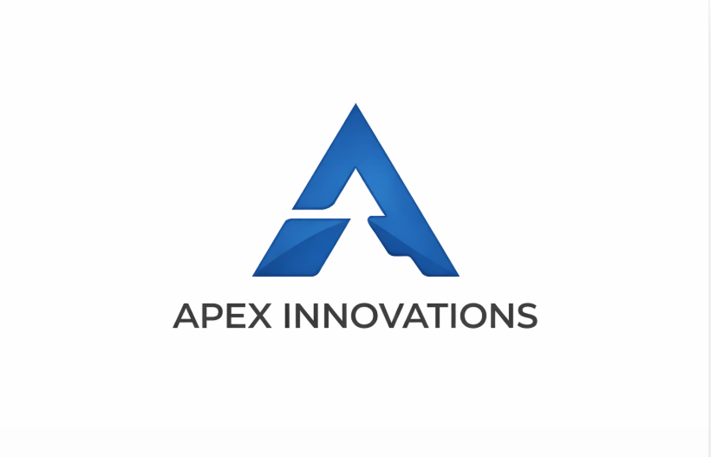
This logo uses geometric shapes to represent stability and precision. The blue color symbolizes trust and professionalism. The minimal design gives a clean and modern appearance
Variations:
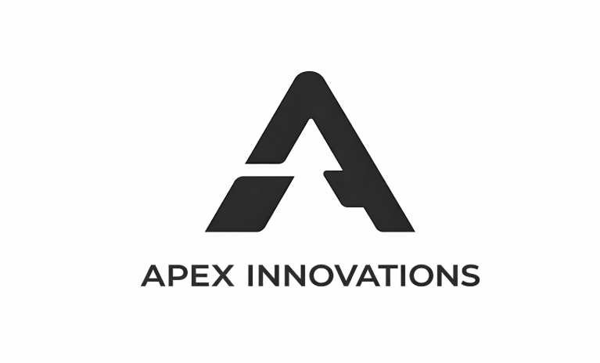
- Full logo
- Monochrome version
- Icon/Favicon

Concept 2: Gradient Dynamics
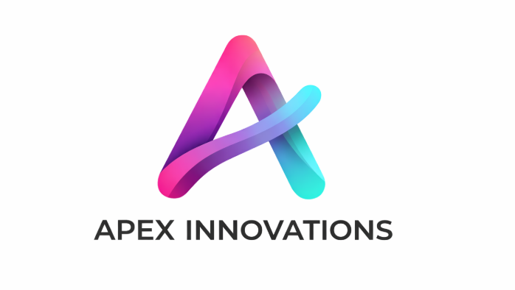
This design uses gradient colors to represent innovation and creativity. The smooth and dynamic shape reflects flexibility and modern design trends.
Variations:
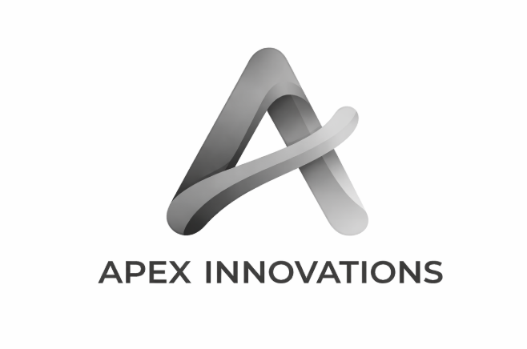
- Full logo
- Monochrome version
- Icon/Favicon
Concept 3: Layered Dimension
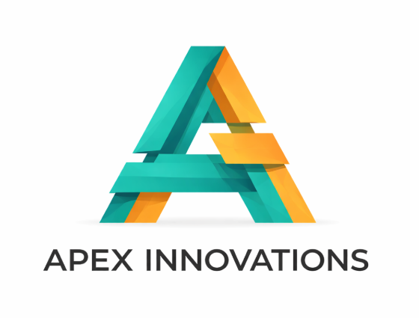
This logo uses layered shapes to represent growth and structure. The combination of colors shows balance and innovation.
Variations:
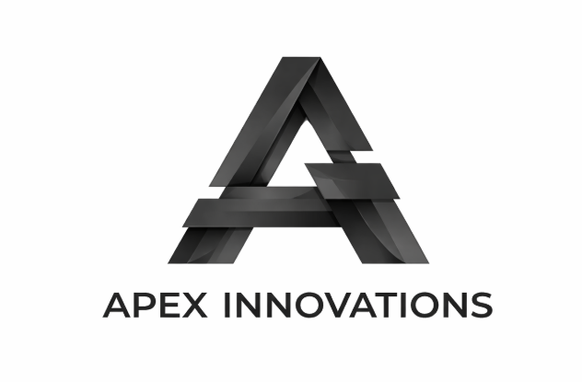
- Full logo
- Monochrome version
- Icon/Favicon
Tools Used:
Canva was used to design and create all logo concepts.

Conclusion:
The redesigned logos successfully improve visual appeal while maintaining brand identity.
Each concept reflects a different modern design approach.

